Boulder Log: A Mobile Application for Tracking Indoor Climbing Progress Through Visual Journaling

Team 04
Thao H. B. Bui – buithao1@cityuniversity.edu
Duy K. Bui - buikhanhduy@cityuniversity.edu
Xavier Soto - sotoxavier@cityuniversity.edu
School of Technology and Computing, City University of Seattle
CS624_01_IN: Full-Stack Dev – Mobile App
Professor Sivakumar Visweswaran
August 23, 2026

Abstract

Indoor climbers often attempt the same boulder problems across multiple sessions while working to improve technique and route-reading skills yet lack a structured way to track this progress. This paper presents Boulder Log, a cross-platform mobile application built with React Native that functions as a visual diary for indoor climbing. Users can photograph boulder problems, log attempts and completions, record notes on difficulty and technique, and set goals to track improvement over time. The system uses a Node.js/Express backend with MongoDB for data storage and AWS S3 for images, supporting cross-device sync. This paper describes the application's phased feature roadmap, from core problem-logging to social sharing and community features, and discusses key implementation considerations including image handling, progress tracking, and scaling a mobile application under active development.

Keywords: Mobile Application Development, Indoor Climbing, Progress Tracking, Visual Journaling

- INTRODUCTION

Indoor climbing particularly bouldering is becoming increasingly popular, yet climbers often lack the tools to track their training systematically; details such as attempted boulder problems, success and failure rates, techniques used, and progress over time are frequently remembered only in a fragmented way. Addressing this need, the team developed Boulder Log, a mobile app that serves as a visual journal for indoor climbers, allowing them to photograph and save boulder problems, log attempts and completions, add notes on difficulty and technique, set improvement goals, and review their training history over time.

The project was developed by three members as part of a mobile application development course, utilizing React Native for the user interface, Node.js/Express for the backend, MongoDB for data storage, and AWS S3 for image storage. The application meets the project's core requirements: at least three navigable screens (Home, Dashboard, Settings), full CRUD functionality, persistent storage via AsyncStorage, and an intuitive, user-friendly interface. Future expansion plans aim to include cross-device data synchronization, social media achievement sharing, user authentication, and community features for rock climbing.

- LITERATURE REVIEW

  - Project Description

This project aims to support individuals looking to improve their indoor climbing performance by tracking their progress and skill level, as well as assisting them in planning their growth. Primarily, it allows climbers to store their climbing records in the form of images or videos alongside detailed metadata, such as difficulty level, progress status, or relevant skill sets. It also provides a statistical dashboard for users to monitor their development over time. Additionally, the application features a planning interface where climbers can set future projects and schedule weekly training routines. As the project scales, community-oriented features such as media sharing and record comparisons will be integrated.

  - Usefulness

Several existing solutions attempt to address this space, with the most notable in the community being the Stōkt mobile app. Stōkt allows users to create climbing problems and share them with others. However, problems created in Stōkt are based on fixed wall layouts, whereas commercial climbing gyms frequently reset "dynamic" walls. Acknowledging this limitation, Boulder Log enables users to upload and share the newest problems currently available at their local gym.

Furthermore, community interaction and skill development in climbing are heavily media-driven. Watching video content (such as Instagram Reels or video logs) provides significantly more context regarding route execution and beta (movement solutions) than a static image. For this reason, uploading and sharing execution videos is critical to the app's overall utility and user engagement.

From an academic perspective, integrating visual journaling into sports training is strongly supported by research in motor learning and observational skill acquisition. Studies demonstrate that video feedback and self-modeling accelerate the refinement of physical movements by allowing athletes to visually analyze technique and correct spatial errors (Wishart et al., 2000; Middlemas & Harwood, 2018). In bouldering, success depends heavily on movement efficiency and route problem-solving ("beta"), visual recall plays an important role in skill development. By coupling athletic tracking with visual media, Boulder Log bridges the gap between quantitative logging and observational skill acquisition.

- METHODOLOGY

  - Project Tools

The development process was carried out in GitHub Codespaces, providing every team member with a consistent, browser-accessible environment without local setup differences.

- Architecture and design research: Comparing navigation approaches (React Navigation versus Expo Router file-based routing) and data-storage patterns (local-only AsyncStorage versus local-first with backend sync) before committing to an implementation.
- Scaffolding and iteration: Generating initial component and screen implementations from wireframe mockups, which were then reviewed, tested, and refined by the team.
- Debugging support: Diagnosing environment-specific issues (Codespaces port visibility, Expo tunnel connectivity, .env configuration errors, and platform-specific path-encoding differences between Windows and Linux/Codespaces environments) that arose during integration testing.

  - Use Cases

The primary actor is a climber using the app to log and review their indoor bouldering progress. Core use cases:

Use Case | Description
Log a new problem | User photographs a boulder problem, assigns a grade (V-scale), records initial attempt count, adds a comment, and optionally tags gear used
View problem history | User browses previously logged problems from the Home screen and opens any one for detail
Update problem progress | User updates attempt count, marks a problem as sent, edits notes, or changes tagged gear
Delete a problem | User removes a logged problem that was added in error or is no longer relevant
Track climbing statistics | User views aggregate stats (total logged, send rate, activity this week) derived automatically from logged problems
Manage gear inventory | User adds new gear items, updates gear condition as it wears, and views gear tagged to specific problems
Sync across devices | User's data persists locally and synchronizes with a backend so it is available if the app is reinstalled or used on a different device

  - UI Wireframe Mockups

Before implementation, high-fidelity HTML/CSS mockups were built for all four core screens to validate the visual design system and information hierarchy prior to writing React Native code. The mockups established:
- A consistent color-coding convention borrowed directly from real climbing gyms like grade and gear condition are both represented using the same green, yellow, orange, red "route tape" scale, so status is legible briefly regardless of context.
- A signature "chalk tally mark" visualization for attempt counts, reinforcing the app's diary/logbook framing rather than a generic counter.
- Consistent card and section patterns (horizontal scroll rows, block-with-update-action pattern) reused across screens to reduce visual inconsistency.

Figure 1 illustrates our Home screen, which displays a weekly summary of the climber's activity through three stat cards; total problems logged, send rate, and activity this week; along with a "Recent" section listing the most recently logged ascents. Bottom tab navigation provides access to the Home, Logbook, and Profile screens.

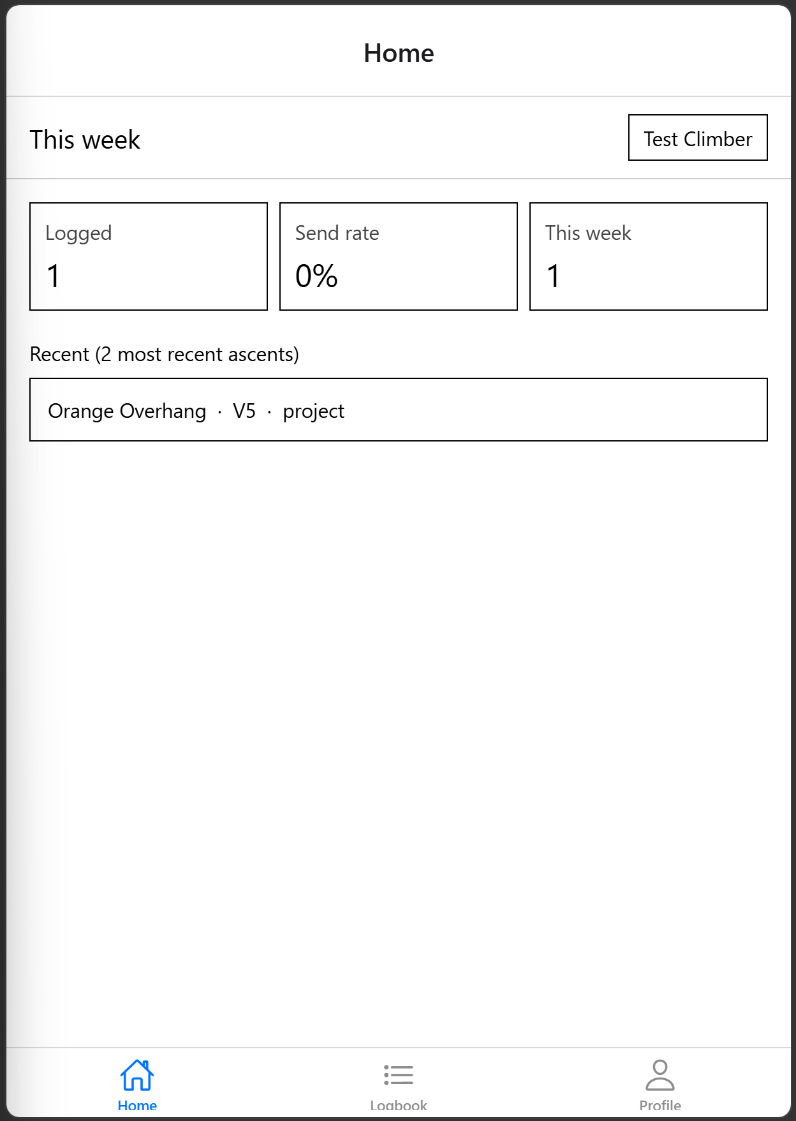
Figure 1: Home Screen
Figure 2 illustrates the Ascent detail screen, where a climber can view and edit the full record for a single logged problem including route name, grade, attempt count, status, and free-text notes. The screen also provides fields for attaching photos via a "Pick photos" action, along with Save and Delete controls for updating or removing the entry.

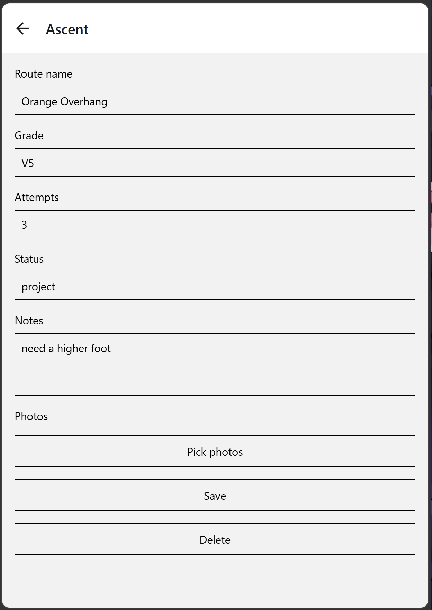
Figure 2: Ascent Detail Screen
Figure 3 illustrates the Logbook screen, which lists all the climber's logged ascents under a "My sends" summary showing total climbs and sends. Each entry displays the route name, grade, attempt count, status, and notes, with a "+ Log" action available to add a new ascent directly from this screen.

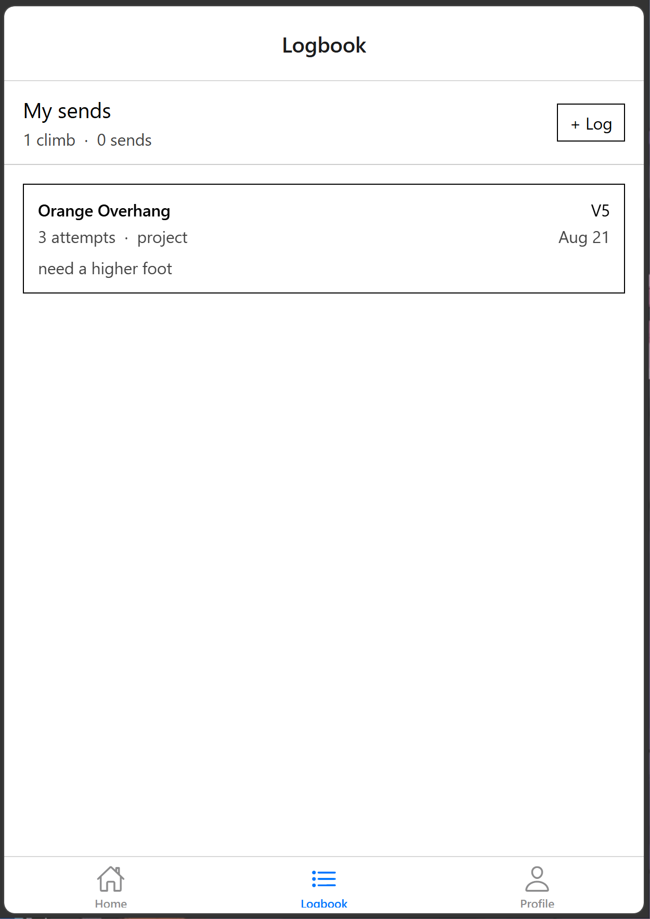
Figure 3: Lookbook Screen

  - Architecture

The application follows a three-tier architecture. The client, built with React Native and Expo Router, handles UI rendering, local state, and local persistence via AsyncStorage; it uses Expo Router's file-based routing rather than a manually configured navigator, so each screen file directly corresponds to a route.

The server, built with Node.js and Express, exposes a REST API with CRUD endpoints for two resources, Problems and Accessories. It runs independently of the Expo dev server and is reachable during development through a forwarded Codespaces port. The database, MongoDB Atlas, is a cloud-hosted document store holding the Problem and Accessory records, connected to the Express server via Mongoose.

A local-first synchronization pattern sits between the client and server that every create/update/delete operation writes to AsyncStorage immediately. Therefore, the UI updates instantly and the app remains usable offline), then fires a background network request to the Express API. If the network request fails, the local copy remains authoritative until the next successful sync. This design choice was made specifically to keep the app resilient to the connectivity issues encountered during development

Image capture is planned to use a pre-signed URL pattern with AWS S3 that client requests a short-lived upload URL from the server, uploads the image directly to S3, then stores only the resulting URL in MongoDB rather than routing image bytes through the Express server, avoiding unnecessary server bandwidth and avoiding storing large binary data directly in MongoDB documents which are subject to a 16MB size limit.

  - React Components, Functions, and Hooks

Screens (Route Components):
- HomeScreen (app/index.tsx): root screen composes the stats strip and both scrollable rows.
- ProblemDetailScreen (app/problem/[id].tsx): dynamic route, reads a problem by ID.
- UploadScreen (app/problem/upload.tsx): dual-purpose add/edit form, driven by an optional id query parameter.
- AddGearScreen (app/gear/add.tsx): gear creation form.

Reusable components:
- ProblemCard: renders a single problem thumbnail with grade tab and attempt count.
- GearCard/AddGearCard: renders a gear item or an "add new" affordance in the accessories row.
- TallyMarks: renders an attempt count as grouped chalk-mark SVG strokes rather than a plain number.

Data-layer functions (utils/storage.ts):
- getProblems(), addProblem(), updateProblem(), deleteProblem()
- getAccessories(), addAccessory(), updateAccessory(), deleteAccessory()
- computeStats(): pure function deriving the three Home-screen statistics from the in-memory Problems array.

Hooks used:
- useState/useEffect: local component state and data loading on mount.
- useFocusEffect (React Navigation, re-exported through Expo Router): reloads data every time a screen regains focus, ensuring the Home screen reflects changes made on the Upload or Detail screens without requiring a manual refresh.
- useLocalSearchParams: reads dynamic route parameters (id) in the Detail and Upload screens.
- useRouter/useNavigation: programmatic navigation and screen title configuration.

  - Component Interaction & Sequence Diagram

The most representative interaction is logging a new problem, which touches every layer of the architecture:
- User opens UploadScreen from the Home screen's floating action button.
- User captures a photo (expo-image-picker), selects a grade, enters a comment, and optionally selects tagged gear.
- On save, UploadScreen calls addProblem().
- addProblem() writes the new record to AsyncStorage immediately and returns control to the UI, which navigates back to HomeScreen.
- addProblem() also issues a background fetch POST request to the Express API.
- The Express route validates the payload and writes it to MongoDB via Mongoose.
- On next focus, HomeScreen's useFocusEffect calls getProblems(), which returns the local (already-updated) list immediately and separately attempts a background refresh from the server, reconciling any differences.

Figure 4 illustrates the sequence for logging a new boulder problem, from the Upload screen through addProblem() in the data layer. The flow then splits into two parallel paths: an instant local write to AsyncStorage, and a background sync via the Express API that persists the record to MongoDB Atlas. Both branches converge back at the Home screen, which reflects the update the next time it regains focus.

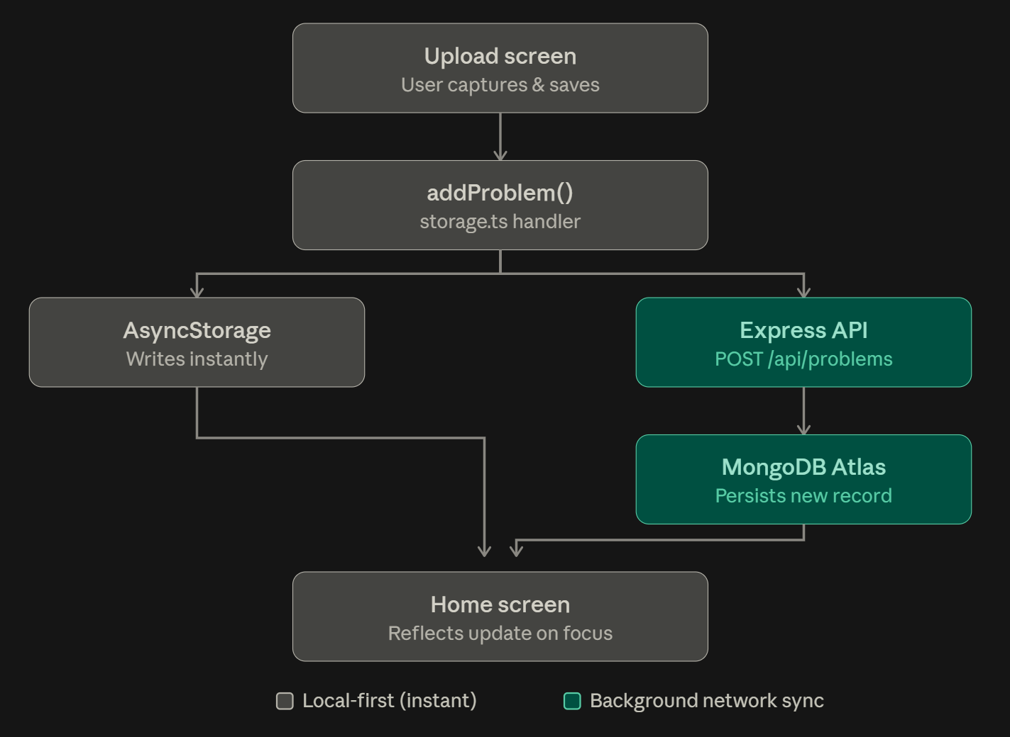
Figure 4: Data Flow
  - Component/Function Tree Hierarchy

Figure 5 shows the file and component tree of the Boulder Log frontend, where each screen under app/ maps directly to a route via Expo Router's file-based navigation. Shared utilities sit outside the route tree and are consumed by all screens and components.

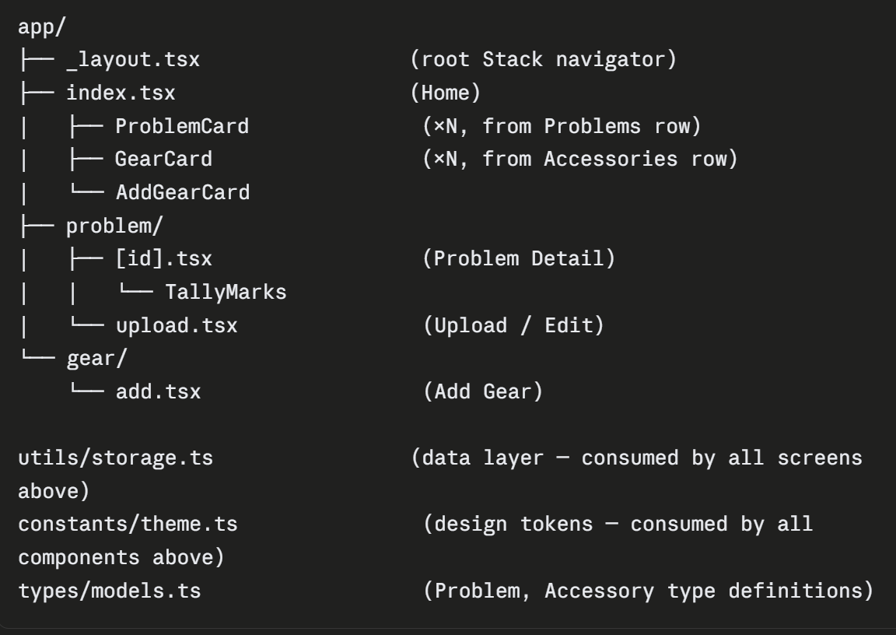
Figure 5: Project Directory Structure
- FIGURES/TABLES

Figure 6 illustrates our team system architecture diagram.
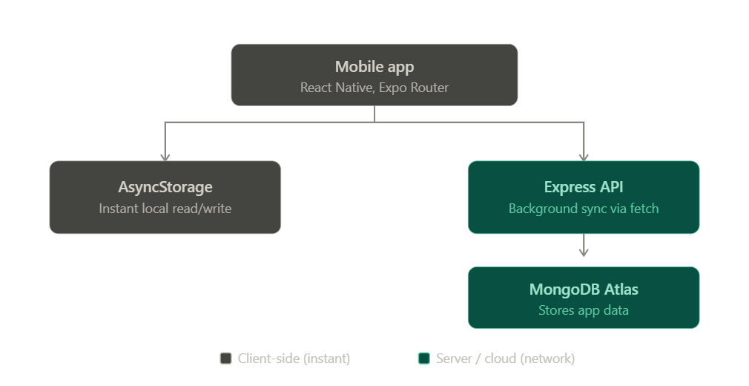
Figure 6: System Architecture Diagram
Field | Type | Description
_id | string | Unique identifier
name | string | Problem name/label
grade | string | V-scale grade (e.g. V5)
imageUrl | string | Captured photo, local URL
attempts | number | Total attempt count
status | “working”|”sent” | Completion state
notes | string | Free-text comment
accessoryIds | string | Gear tagged to this problem
dateAdded | ISO date string | Used for “this week” stat calculation
Table 1: Problem Data Model
Field | Type | Description
_id | string | Unique identifier
userId | string | Placeholder value pending authentication
name | string | Gear name
category | “shoes”|”chalk”|”other” | Gear type
condition | “good”|”low”|”worn_out” | Current condition
dateAdded | ISO date string
Table 2: Accessory Data Model

- CONCLUSION

This project delivered a four-screen React Native app for tracking indoor climbing progress, meeting the assignment's core requirements including Expo Router navigation, full CRUD across Problems and Accessories, AsyncStorage persistence, and a self-built Express/MongoDB backend while adding a local-first sync strategy to keep the app usable when the backend is unreachable.

Development also surfaced practical lessons such as distinguishing forwarded ports across services, restarting processes after environment-variable changes, and platform-specific bundler quirks (Windows path encoding) not seen in Linux-based containers.

- REFERENCES

Middlemas, S., & Harwood, C. (2018). No place to hide: Football players' and coaches' perceptions of the psychological factors influencing video feedback. Journal of Applied Sport Psychology, 30(1), 23–44. https://doi.org/10.1080/10413200.2017.1302020
Wishart, L. R., Lee, T. D., Murdoch, J. E., & Hodges, N. J. (2000). Effects of aging on automatic and effortful processes in bimanual coordination. The Journals of Gerontology: Series B, 55(2), P85–P94. https://doi.org/10.1093/geronb/55.2.P85
Dabit, N. (2019). React Native in action. Manning Publications. https://www.manning.com/books/react-native-in-action

- WORKLOAD ASSIGNMENT

Thao:
- Development of the four-screen React Native application interface.
- Implementation of Expo Router for screen navigation and passing dynamic route parameters (e.g., id in Detail and Upload screens).
- Managing local component state and data loading using useState and useEffect hooks.
Duy:
- Construction of the Express API backend.
- Integration with MongoDB via Mongoose, including the implementation of the Problem and Accessory data schemas.
- Handling server-side validation and background fetch POST requests from the client application.
Xavier:
- Implementation of the local-first sync strategy and data persistence using AsyncStorage.
- Integration of expo-image-picker for photo capture functionality on the Upload screen.
- Managing data synchronization and UI updates utilizing the useFocusEffect hook to reconcile local and server data.

